**Problem Analysis**

If we are to use the computer as a problem-solving tool, then we must have a good analysis of the problem given. Here are some suggested steps on how to go about analyzing a certain problem for computer application:

1. Review the problem carefully and understand what you are asked to do.

2. Determine what information is given (input) and what result must be produced (output).

3. Assign names to each input and output items.

4. Determine the manner of processing that must be done on the input data to come up with the desired output (i.e., determine what formulas are needed to manipulate the given data).

***Example***

Given the scores for the two departmental quizzes, two machine projects, final exam, and teacher's evaluation, write a program that will compute for the final grade based on the following computation:

50% Average of two departmental quizzes

+15% average of 2 machine projects

+30% Final exam

+5% Teacher’s evaluation

### [Definition of Algorithm](https://www.edrawsoft.com/algorithm-definition.php)

A logical step-by-step method to solve the problem is called algorithm, in other words, an algorithm is a procedure for solving problems. In order to solve a mathematical or computer problem, this is the first step of the procedure. An algorithm includes calculations, reasoning and data processing. Algorithms can be presented by natural languages, pseudo code and flowcharts, etc.

### [Definition of Flowchart](https://www.edrawsoft.com/Flowchart-Definition.php)

A flowchart is the graphical or pictorial representation of an algorithm with the help of different symbols, shapes and arrows in order to demonstrate a process or a program. With algorithms, we can easily understand a program. The main purpose of a flowchart is to analyze different processes. Several standard graphics are applied in a flowchart:

* Terminal Box - Start / End

Terminal Box Figure

* Input / Output

Input / Output Figure

* Process / Instruction

Process Figure

* Decision

Decision Figure

* Connector / Arrow

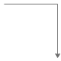

The graphics above represent different part of a flowchart. The process in a flowchart can be expressed through boxes and arrows with different sizes and colors. In a flowchart, we can easily highlight a certain element and the relationships between each part.

### How to Use Flowcharts to Represent Algorithms

Now that we have the definitions of algorithm and flowchart, how do we use a flowchart to represent an algorithm?

Algorithms are mainly used for mathematical and computer programs, whilst flowcharts can be used to describe all sorts of processes: business, educational, personal and of course algorithms. So flowcharts are often used as a program planning tool to visually organize the step-by-step process of a program. Here are some examples:

**Example 1: Convert Temperature from Fahrenheit (℉) to Celsius (℃)**

**Algorithm:**

Step 1: Read temperature in Fahrenheit,

Step 2: Calculate temperature with formula C=5/9*(F-32),

Step 3: Print C,

**Flowchart:**

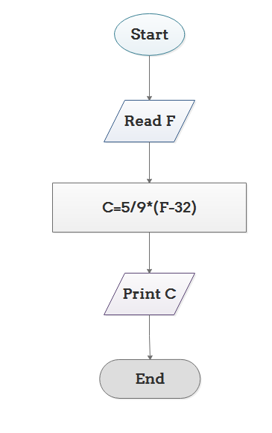

**Example 2: Print 1 to 20:**

**Algorithm:**

Step 1: Initialize X as 0,

Step 2: Increment X by 1,

Step 3: Print X,

Step 4: If X is less than 20 then go back to step 2.

**Flowchart:**

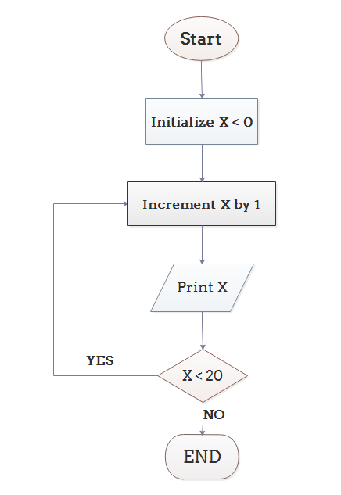

3. Draw the flow chart for finding largest of three numbers and write an algorithm and explain it.

Solution

***Algorithm:***

1.  Start

2.  Input A,B,C

3.  If (A>B) and (A>C) then print “A is greater”.

Else if (B>A) and (B>C) then print “B is greater”.

Else print “C is greater”.

4.  Stop

